Name: _________________________________ Date: ________________________ Period: _______

No Red Ink Embedding Evidence
Part 1: Students can provide a strong speaker, listener, and plot clue when using evidence from a literary source.
Context for Literary Evidence 1: Identifying Speaker, Listener, and Plot Clue
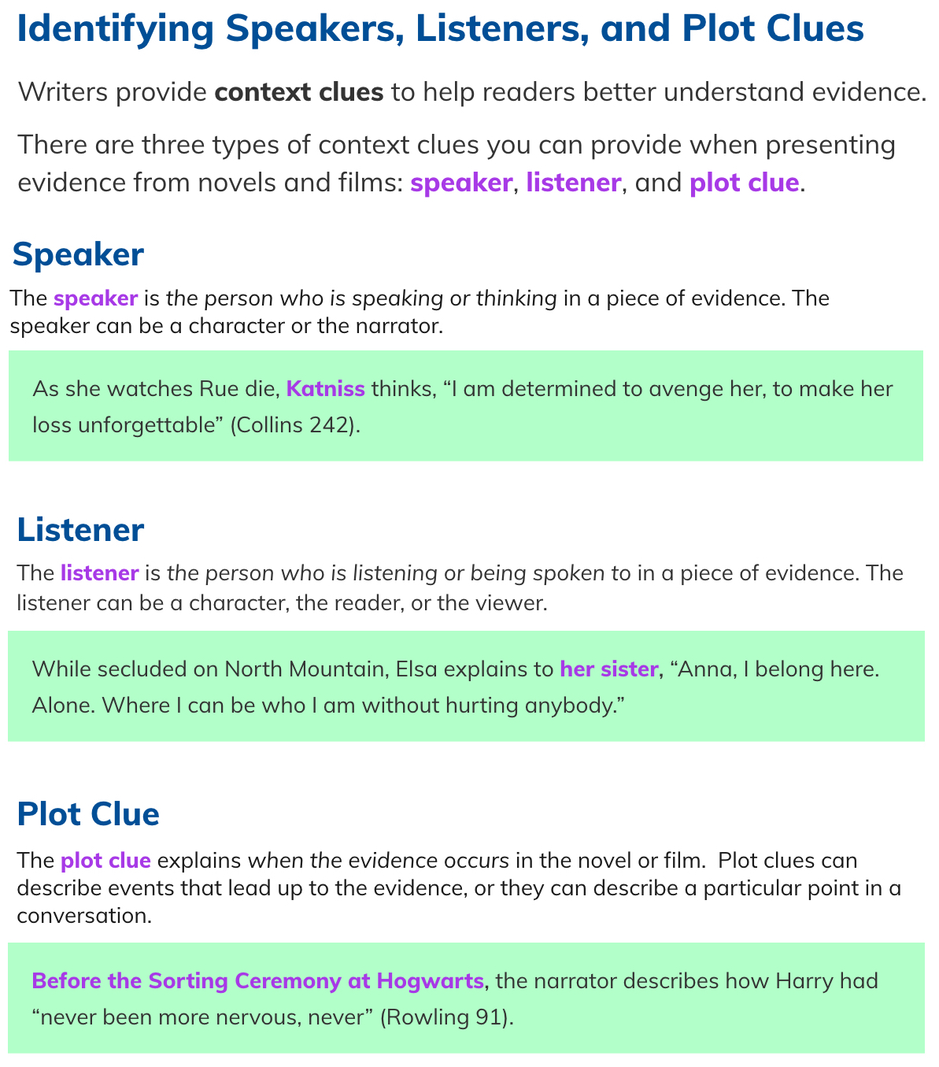
NRI Embedding Evidence -- Page 2

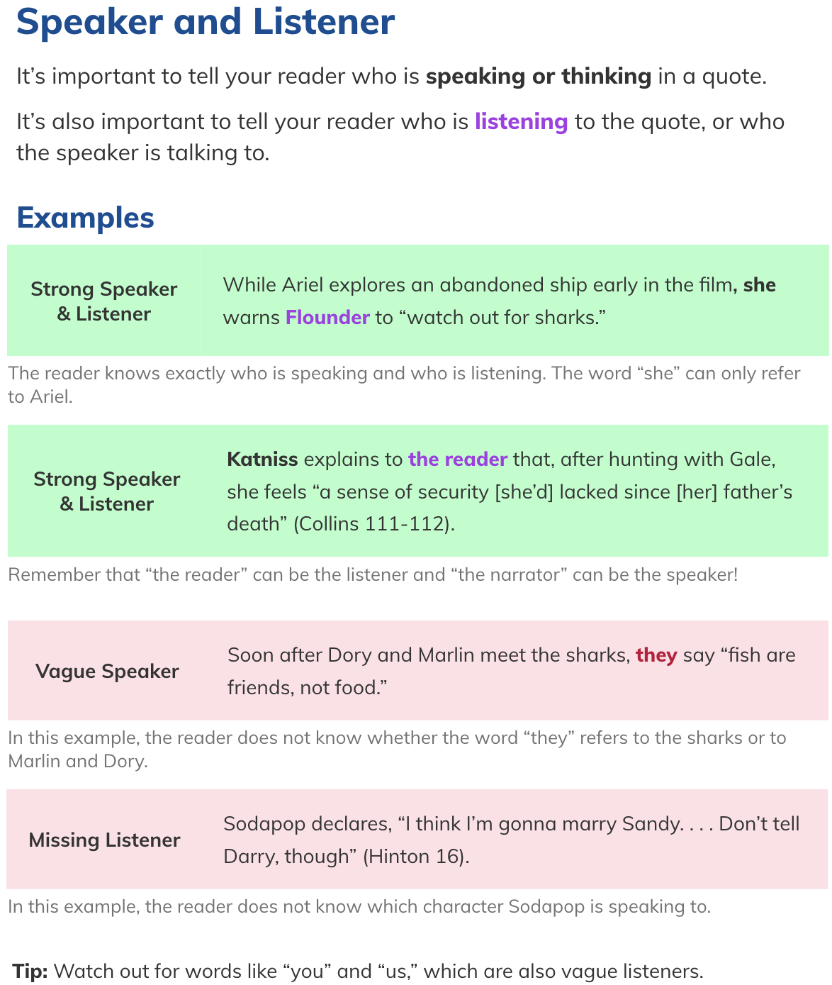
Context for Literary Evidence 2: Evaluating Speaker, Listener, and Plot Clue

NRI Embedding Evidence -- Page 3

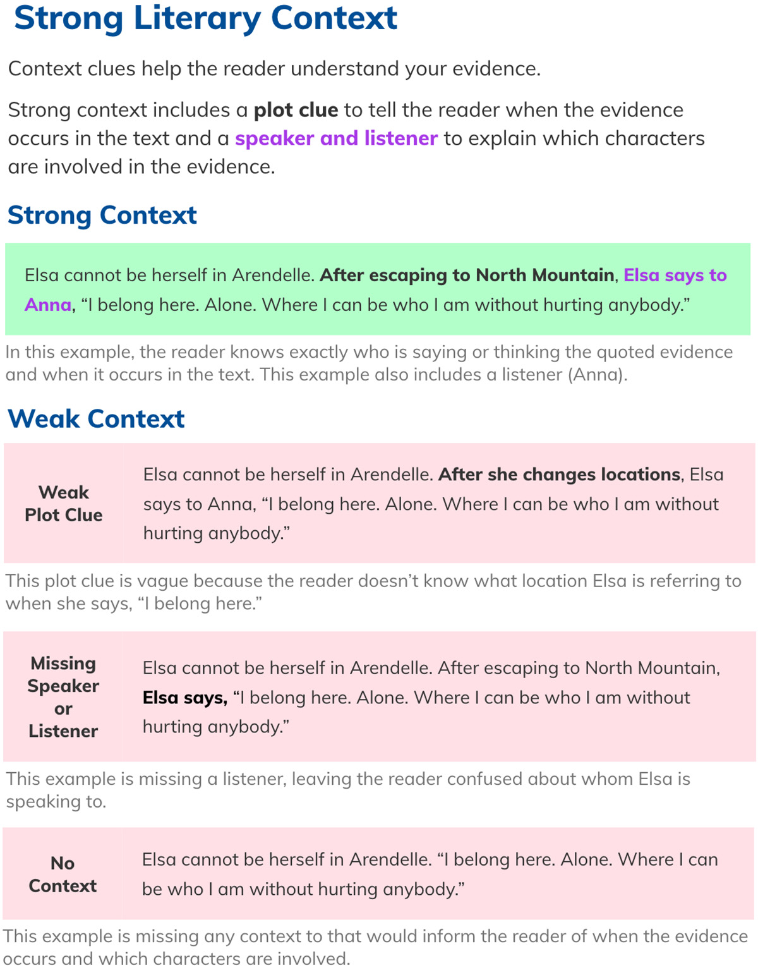
Checkpoint: Providing Strong Context for Literary Evidence

NRI Embedding Evidence -- Page 4

HINT: Identifying the parts of a quote in NRI
Like most lessons in NRI, once you know the trick to what they are asking, it becomes fast and easy to click the right answers. So Let’s get you in on the trick. We’ll use the following paragraph to show how to find the parts NRI wants you to identify.

Harry and Ron had been friends from the first time they had met. When
Ron found out Harry had been chosen for the Tri-Wizard Cup competition,
he said to Harry, “How did you put your name in the cup since you are underage?
You could at least tell your best friend.”

Steps: 1. Go to the first “ mark and look backwards
2. Who is talking = Speaker and the person spoken to = Listener
3. The rest of the sentence with the Speaker / Listener = Plot Clue
4. Opening sentence, if there is one = Context

When you go to the first quotation mark (“) you see the words “How did you …” Now look backwards, before the quotation mark. You see the Speaker and the Listener. Note: sometimes there is not a speaker or a listener. But here we get:

Speaker: he said to Harry, Listener: he said to Harry,

The rest of the sentence that has “he said to Harry” is called the Plot Clue. Here it is:

Plot Clue: When Ron found out Harry had been chosen for the
Tri-Wizard Cup competition

OK so far? That was the hard part. If there is a sentence before the Plot Clue it’s called the Context. In this paragraph the Context introduces time and place for the quote:

Context: Harry and Ron had been friends from the first time they had met.

And all that leaves is the quote itself, and that’s the stuff between the quotation marks:

Quote: “How did you put your name in the cup since you are underage?
You could at least tell your best friend.”
NRI Embedding Evidence -- Page 5

HINT: Using the NRI words to your advantage
Why does this matter? If you know these parts of a paragraph then you’ll know what you need to include when you write your own paragraphs. You will start with a Topic Sentence – which we discuss in other worksheets. Next add in your evidence. Use these parts of a quote when you HUG in your quotes. Here is an example of adding quotes in an essay about Macbeth:

Macbeth sat alone in his castle when he heard that his wife had killed herself. Feeling no emotion and despairing for life itself, Macbeth said to no one in particular, “She should have died hereafter, there would have been a time for such a word” (V.v.17). Shakespeare includes this brief comment to show how little Macbeth is upset by the death of his long-time partner. Macbeth has realized that nothing matters any longer to his life since he has become completely isolated in his castle. Macbeth continued, talking to himself, to comment that, “Life is a tale told by an idiot … signifying nothing.” Here, the author …

The paragraph HUGS in some evidence – a quote from Macbeth. This quote has all of the following (1) Context, (2) Plot Clue, (3) Speaker, (4) Listener, and (5) Quote and (Citation).
Context: Macbeth sat alone in his castle when he heard that his wife had killed herself.
Plot Clue: Feeling no emotion and despairing for life itself,
Speaker: Macbeth said Listener: to no one in particular,
Quote: “She should have died hereafter, there would have been a time for such a word.”
Citation: (V.v.17)

Great. All the pieces are here. You have hugged in your quote – almost. As of now, it’s just a one-armed hug. You need to get the other arm involved now. You can close the hug by giving an explanation of why the quote you have included matters. And you do that twice.

1. You explain first why the quote matters to the original text / author:
First Shakespeare includes this brief comment to show how little Macbeth is upset by the death of his long-time partner.

2. You then explain why you are including this quote to support your assertion:
Macbeth has realized that nothing matters any longer to his life since he has become completely isolated in his castle.

NRI Embedding Evidence -- Page 6

HINT: Standard Template for a Paragraph
Use this system to save time and get organized. Here is what a standard, ready-to-go, official paragraph looks like. Yes, you can play with the format and style – later, once you’ve got the standard form down. If you want to know how to get started, or if you have included everything the reader is looking for – just check this list.

Topic Sentence (explains the main theme or idea of the paragraph)

Quote 1 Context / Plot Clue / Speaker / Listener
“Quote 1” (Citation)
Q1 Explanation 1 – why this matters to the original text
Q1 Explanation 2 – why this matters to your paper

Quote 2 Context / Plot Clue / Speaker / Listener
“Quote 2” (Citation)
Q2 Explanation 1 – why this matters to the original text
Q2 Explanation 2 – why this matters to your paper

Conclusion to the Paragraph (ties back to the Topic Sentence)

_____________________________________________________________________________

HINT: Remember to use transition words to introduce the second quote, or even at the start of the paragraph, especially when your paragraph is part of a longer essay.

Name ____________________________________ Date ______________________ Period _________

Hugging Quotes: Parachutes vs. Hugs

Parachutes: When you include a quote in something you are writing, you cannot just drop it in as if the quote would parachute into place in the paragraph. A quote that parachutes in is where you drop a quote in without any warning. The reader does not know who said the words, where, when or how. There’s no introduction, no context, nothing but a set of quotation marks.

Hugs: When you hug a quote, you use both arms. On one side of the quote you introduce who is saying these words, where and when. Then, on the other side of the quote, you explain why the quote matters to the original text, and why it matters to you – why did you bother adding this quote to your paper? How does the quote support your assertion?

Here is an example of a parachute drop:
Macbeth is angry with his wife but still loves her. “She should have died hereafter; There would have been a time for such a word.” His castle is surrounded and he must think about himself.

Here is a quote that has been hugged:
Macbeth is angry with his wife but still loves her. At the same time, Macbeth wonders what really matters in his life. So, as his wife dies in Act 5, scene 5, Macbeth sits by himself and talks out loud to himself, saying, “She should have died hereafter; there would have been a time for such a word” (5.5.17). Shakespeare pictures Macbeth telling himself he does not have time to mourn his wife’s death, as an enemy army approaches, and as his own hopes dwindle and die. This proves how little Macbeth cares about life …

Think of hugging a quote as an:

Introduction + Quote & + Explanation
Setting, Person Citation Reason why you
Text being quoted used the quote

Or, think of hugging as answering the following questions:

Who said it, and to whom? What was said? Why does this matter to the text?
When did they say it? Why does this matter to my essay?
Where in a text is the quote found?
Hugging Quotes Worksheet 1 -- Page 2

Directions: In the exercises below, please make reference to the following text, the following poem “ ‘Twas the Night Before Christmas,” by Clement Clarke Moore. Start by reading the text and looking for (1) literary devices and (2) descriptions of St. Nick’s appearance and character.

'Twas the night before Christmas, when all through the house
Not a creature was stirring, not even a mouse;
The stockings were hung by the chimney with care,
In hopes that St. Nicholas soon would be there;
The children were nestled all snug in their beds,
While visions of sugar-plums danced in their heads;
And mamma in her 'kerchief, and I in my cap,
Had just settled down for a long winter's nap,
When out on the lawn there arose such a clatter,
I sprang from the bed to see what was the matter …
When, what to my wondering eyes should appear,
But a miniature sleigh, and eight tiny reindeer,
With a little old driver, so lively and quick,
I knew in a moment it must be St. Nick.
More rapid than eagles his coursers they came,
And he whistled, and shouted, and called them by name;
"Now, DASHER! now, DANCER! now, PRANCER and VIXEN!
On, COMET! on CUPID! on, DONNER and BLITZEN!
To the top of the porch! to the top of the wall!
Now dash away! dash away! dash away all …"
And then, in a twinkling, I heard on the roof
The prancing and pawing of each little hoof.
As I drew in my hand, and was turning around,
Down the chimney St. Nicholas came with a bound.
He was dressed all in fur, from his head to his foot,
And his clothes were all tarnished with ashes and soot;
A bundle of toys he had flung on his back,
And he looked like a peddler just opening his pack.
His eyes -- how they twinkled! his dimples how merry!
His cheeks were like roses, his nose like a cherry!
His droll little mouth was drawn up like a bow,
And the beard of his chin was as white as the snow;
Hugging Quotes Worksheet 1 -- Page 2

The stump of a pipe he held tight in his teeth,
And the smoke it encircled his head like a wreath;
He had a broad face and a little round belly,
That shook, when he laughed like a bowlful of jelly.
He was chubby and plump, a right jolly old elf,
And I laughed when I saw him, in spite of myself;
A wink of his eye and a twist of his head,
Soon gave me to know I had nothing to dread;
He spoke not a word, but went straight to his work,
And filled all the stockings; then turned with a jerk,
And laying his finger aside of his nose,
And giving a nod, up the chimney he rose;
He sprang to his sleigh, to his team gave a whistle,
And away they all flew like the down of a thistle.
But I heard him exclaim, ere he drove out of sight,
“Happy Christmas to all, and to all, a Good Night.”

Directions: In the following assignment you will have a chance to answer a question about St. Nick’s actions from the poem above. You’ll be given a question to answer. In your answer you’ll need to bring in supporting evidence from the poem. Hug in a quote by introducing it at the start and then explaining how the quote supports your answer at the end. Here’s an example:

EXAMPLE What does Old St. Nick look like?

Intro: The author of the famous poem, “ ‘Twas the Night Before Christmas”
by C. C. Moore, the author tells us of a late-night visitor who showed up
by surprise on Christmas Eve. The author describes St. Nick by saying,

Quote: “He had a broad face and a little round belly that shook when he laughed like a bowlful of jelly. He was chubby and plump, a right jolly
old elf.”

Explanation: From this description the visitor was neither scary nor unwelcome.

Hugging Quotes Worksheet 1 -- Page 3

QUESTION 1 What was the family doing on Christmas Eve?

Intro ________________________________________________________________

________________________________________________________________

Quote ________________________________________________________________

________________________________________________________________

________________________________________________________________

Explanation ________________________________________________________________

________________________________________________________________

________________________________________________________________

QUESTION 2 What did the narrator hear in the middle of the night?

Intro ________________________________________________________________

________________________________________________________________

Quote ________________________________________________________________

________________________________________________________________

________________________________________________________________

Explanation ________________________________________________________________

________________________________________________________________

________________________________________________________________
Hugging Quotes Worksheet 1 -- Page 4

QUESTION 3 Why had St. Nicholas arrived at this house?

__________________________________________________________________________

__________________________________________________________________________

__________________________________________________________________________

__________________________________________________________________________

__________________________________________________________________________

__________________________________________________________________________

__________________________________________________________________________

__________________________________________________________________________

Name: _________________________________ Date: ________________________ Period: _______

No Red Ink Punctuating Quotations

Context for Literary Evidence 1: Dialogue, Flow, and Colon Quotes
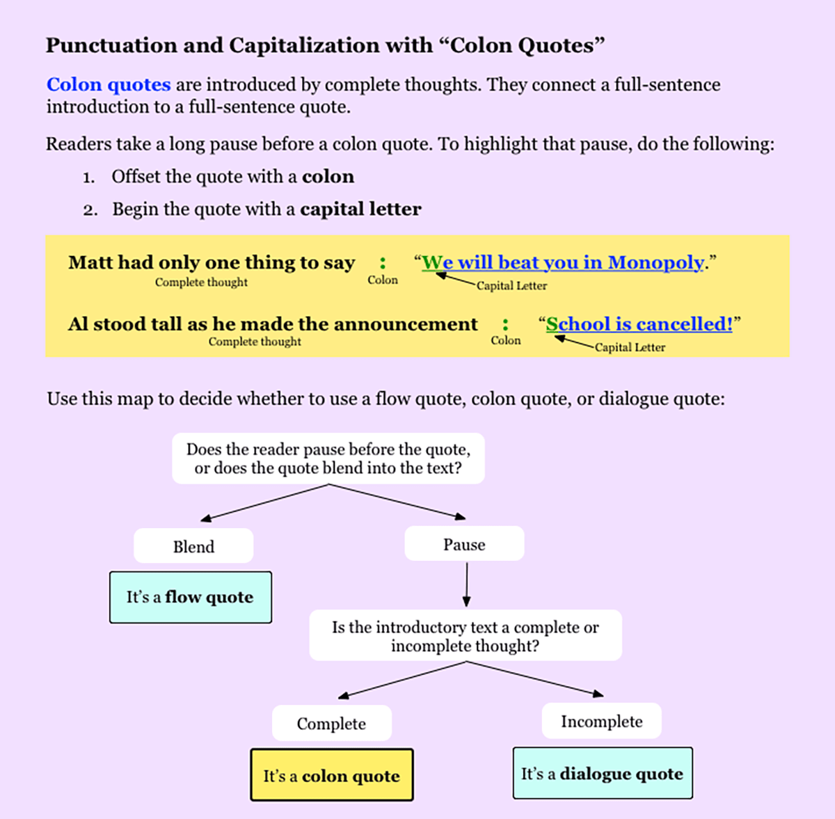

NRI Punctuating Quotations -- Page 2

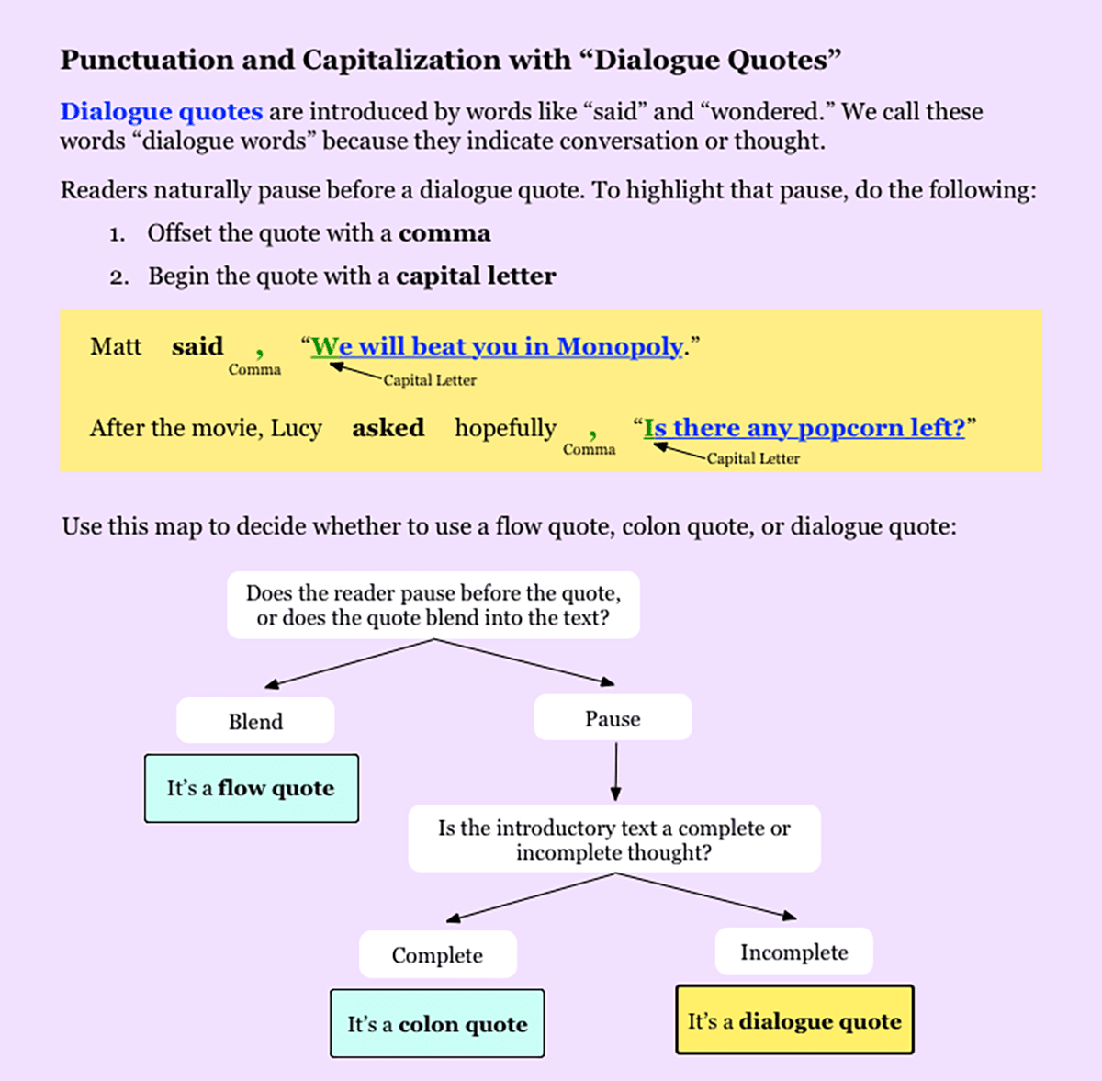

NRI Punctuating Quotations -- Page 3

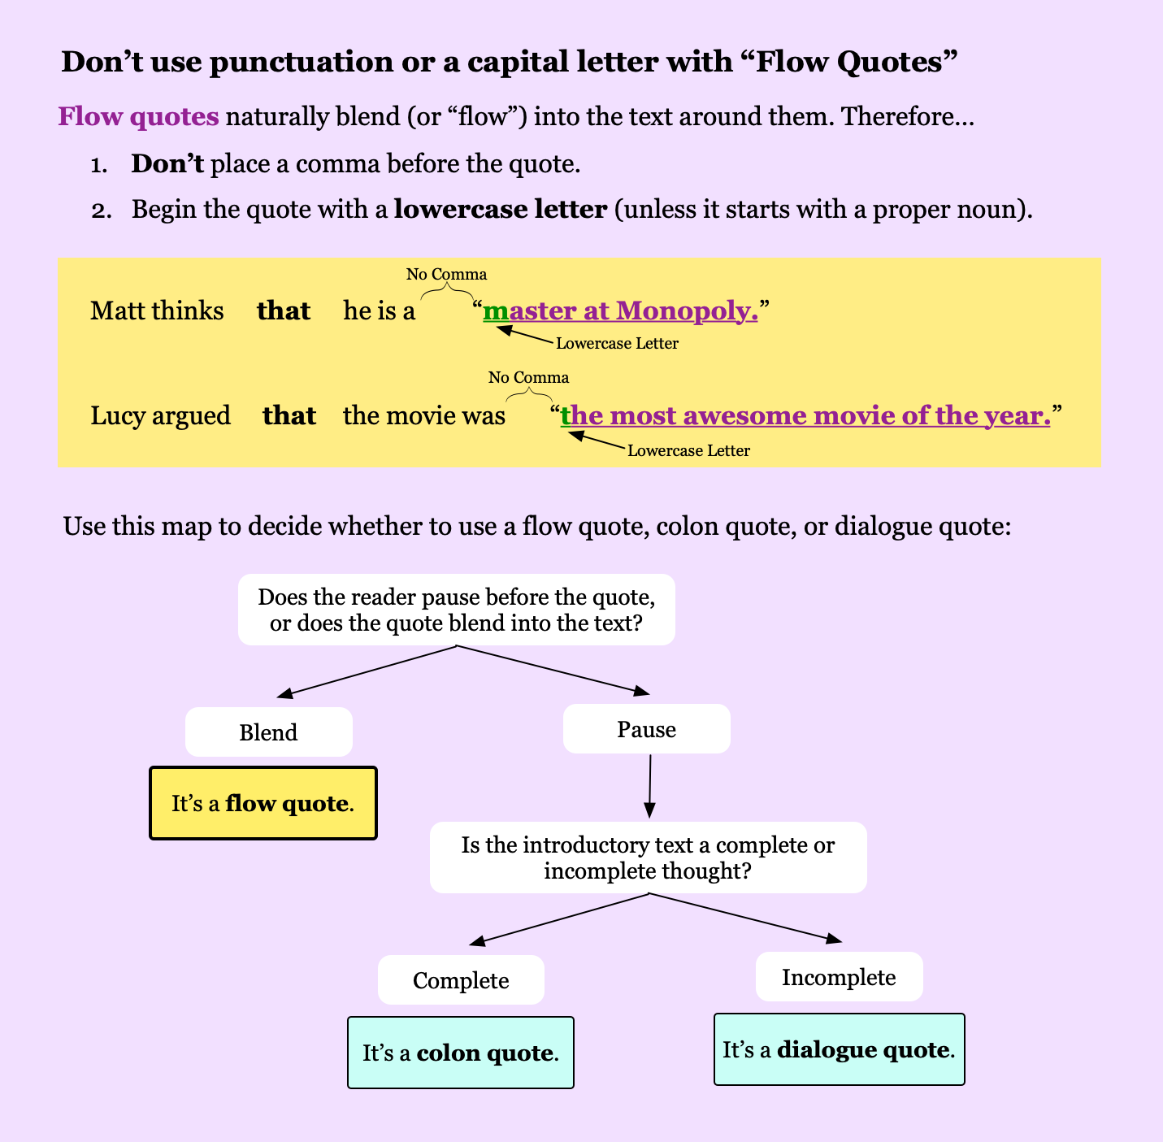

NRI Punctuating Quotations -- Page 4

Adding a Quote: you simply need to remember the 3 C’s
When you want to drop a quote into your sentences you need to use the right punctuation. It’s not that hard to remember though – just think: Comma, Quotation marks, Capital. OK, I know that’s not really 3 C’s, but it sounds like it. And using this reminder is a good process to use when you are including a direct quotation into a sentence. For example, look at this sentence:
Sam said, “I don’t like green eggs and ham.”
To make sure you have used the correct punctuation, use the 3C’s. Start by putting the quotation marks at the start and the end of the direct quotation. Then, if you are adding a full sentence for a quote, make sure you start the quote with a capital letter. Finally, make sure you have a comma to set the quote off from the rest of your sentence. In order that’s Comma, Quotation Mark, Capital. HINT: There will be some times when you will use a colon ( : ) instead of a comma, but let’s not get picky yet. See below for the exceptions to this rule.
Here are some more examples:
“She was not happy about the grade,” Mary said.
Abigail Porter was an author of many books. It was she who had said, “Kill them all!”

Exceptions to this rule:
1. Sometimes a quote will be interrupted. When that happens, you do not need a capital when you return to the quote – just the comma and the quotation marks. Example:
“I do not like green eggs and ham,” he said in anger, “and never will I eat them again!”
2. Sometimes you will only want to quote a part of what someone said. In that case you would not use a capital letter at the start of the part of the quote you are using. So you get:
The reporter said the president was famous for his, “orange tan and his blonde hair.”
Writing in the editorial section, Winkler stated that Olympians were, “dedicated to more than themselves, for they were champions of a whole country.”
3. There may be times when you want to introduce the quotation. That is, you want to explain that someone said something amazing. Then you introduce it and use a colon instead of a comma, but still 3C’s … colon, quotation marks, capital. Here’s what I mean:
Sam said this to his new friend: “I do not like green eggs and ham.” He went on to say something else: “I will not eat them on a train. I will not eat them on a plane.”
Name: _________________________________ Date: ________________________ Period: _______

Punctuating Quotations: Worksheet 1

Directions: From each set of sentences below, choose the sentence with the correct punctuation, if any punctuation is needed, between the writer's words and the quoted words.
OK, you are probably thinking this will be confusing. But it doesn’t need to be. With a little practice this gets easier, especially if you follow the HINTS outlined here:

HINT 1: Look at whether the quote is a full sentence or only part of the original sentence
(1) If the whole quote is used you will need the 3C’s (comma, quotation marks, capital)
(2) If only part of the quote is used (not a full sentence) leave out the capital letter

HINT 2: Look at how the quote is introduced
(1) If the quote is introduced with a phrase like “he said” use a comma ( , )
(2) If the quote is introduced with a full sentence (“he said this to me”) use a colon ( : )

HINT 3: Always use quotation marks and Never use a semicolon ( ; )

EXAMPLE

Ex. Original Quote: “I do not like green eggs and ham, I do not like them Sam I am.”
  - My friend says "I do not like green eggs and ham." (no punctuation)
  - My friend says, "I do not like green eggs and ham."
  - My friend says; "I do not like green eggs and ham."
  - My friend says: "I do not like green eggs and ham."

The first thing you see is that the whole quote is used; that means you’ll need to use a comma. You’ll always use quotation marks so that’s two things you know right off the start. Now, you need to look at the introduction. Answer C is wrong, because you never use a semilcolon. So now, is the introduction a phrase or a full sentence? We see “My friend says” and that’s not a full sentence – a full sentence would have been something like “My friend says this” – so the answer needs a comma. That means the answer must be B – the one with the 3C’s. HINT: Just be careful, not every answer will use the 3C’s.
Punctuating Quotations Worksheet 1 -- Page 2

1. Original Quote: “I do not like green eggs and ham, I do not like them Sam I am.”
  - My friend says "I do not like green eggs and ham." (no punctuation)
  - My friend says, "I do not like green eggs and ham."
  - My friend says; "I do not like green eggs and ham."
  - My friend says: "I do not like green eggs and ham."
- Original Quote: "I would not eat them on a train. I would not eat them on a plane."
  - Mr. S. has said this before "I will not eat them on a plane." (no punctuation)
  - Mr. S. has said this before: "I will not eat them on a plane."
  - Mr. S. has said this before; "I will not eat them on a plane."
  - Mr. S. has said this before, "I will not eat them on a plane."
- Original Quote: “I will not eat them with a goat. I will not eat them on a boat.”
  - The President admitted something funny, saying that she would not eat green eggs or ham “with a goat” or “on a boat." (no punctuation)
  - The President admitted something funny, saying that she would not eat green eggs or ham, “With a goat” or “On a boat."
  - The President admitted something funny, saying that she would not eat green eggs or ham: “with a goat” or “on a boat."
  - The President admitted something funny, saying that she would not eat green eggs or ham; “with a goat” or “on a boat."

Punctuating Quotations Worksheet 1 -- Page 3

- Original Quote: “Sam! If you let me be, I will try them. You will see.”
  - Jay-Z, feeling tired of it all, said “I will try them. You will see.” (no punctuation)
  - Jay-Z, feeling tired of it all, said: “I will try them. You will see.”
  - Jay-Z, feeling tired of it all, said, “I will try them. You will see.”
  - Jay-Z, feeling tired of it all, said; “I will try them. You will see.”
- Original Quote: “And I will eat them here and there. I will eat them anywhere!”
  - Mr. S. finally gave in and agreed to eat green eggs and ham “Here and there, and anywhere.” (no punctuation)
  - Mr. S. finally gave in and agreed to eat green eggs and ham, “here and there, and anywhere.”
  - Mr. S. finally gave in and agreed to eat green eggs and ham: “here and there, and anywhere.”
  - Mr. S. finally gave in and agreed to eat green eggs and ham “here and there, and anywhere.”

Name _____________________________________ Date ___________________ Period _________

Punctuating Quotations: Worksheet 2

Directions: From each set of sentences below, choose the sentence with the correct punctuation, if any punctuation is needed, between the writer's words and the quoted words.
Remember the HINTS from our last worksheet – look at (1) if the whole quote is used as a sentence or if the quote is only part of a sentence. (2) Look at how the quote is introduced – is it with a phrase ( , ) or with a full sentence ( : ). BTW: Thoreau is a very famous American author who chose to give up on civilization and go live in the woods on his own for a while … all of these quotes are famous, except for one. Betcha can guess which one.

- Thoreau asks "If the bell rings, why should we run?"
  - Thoreau asks "If the bell rings, why should we run?" (no punctuation)
  - Thoreau asks, "If the bell rings, why should we run?" (comma, quotation mark, capital)
  - Thoreau asks; "If the bell rings, why should we run?" (semi-colon)
  - Thoreau asks: "If the bell rings, why should we run?" (colon)

- Thoreau says "We are determined to be starved before we are hungry."
  - Thoreau says, "We are determined to be starved before we are hungry."
  - Thoreau says "we are determined to be starved before we are hungry."
  - Thoreau says; "we are determined to be starved before we are hungry."
  - Thoreau says: "We are determined to be starved before we are hungry."

Punctuating Quotations Worksheet 2 -- Page 2

- Thoreau explained why he decided to live in the woods this way "I did not wish to live what was not life, living is so dear; nor did I wish to practice resignation, unless it was quite necessary."
  - Thoreau explained why he decided to live in the woods this way "I did not wish to live what was not life, living is so dear; nor did I wish to practice resignation, unless it was quite necessary." (no punctuation)
  - Thoreau explained why he decided to live in the woods this way, "I did not wish to live what was not life, living is so dear; nor did I wish to practice resignation, unless it was quite necessary."
  - Thoreau explained why he decided to live in the woods this way; "I did not wish to live what was not life, living is so dear; nor did I wish to practice resignation, unless it was quite necessary."
  - Thoreau explained why he decided to live in the woods this way: "I did not wish to live what was not life, living is so dear; nor did I wish to practice resignation, unless it was quite necessary."

- In discussing the struggle between right and wrong, Thoreau said this, “Our whole life is startlingly moral. There is never an instant's truce between virtue and vice.”
  - Thoreau explained life by saying this "There is never an instant's truce between virtue and vice."
  - Thoreau explained life by saying this, "There is never an instant's truce between virtue and vice."
  - Thoreau explained life by saying this: "There is never an instant's truce between virtue and vice."
  - Thoreau explained life by saying this, " There is never an instant's truce between virtue and vice."
Punctuating Quotations Worksheet 2 -- Page 3

- Thoreau explained living in the woods as a way to "practice resignation."
  - Thoreau explained living in the woods as a way to "practice resignation."
  - Thoreau explained living in the woods as a way to, "practice resignation.”
  - Thoreau explained living in the woods as a way to; "practice resignation.”
  - Thoreau explained living in the woods as a way to: "practice resignation.’
- Thoreau explained “I simply decided I could do without internet connections and trying to keep up with all those Kardashians.”
  - Thoreau explained; “I simply decided I could do without internet connections and trying to keep up with all those Kardashians.”
  - Thoreau explained “I simply decided I could do without internet connections and trying to keep up with all those Kardashians.”
  - Thoreau explained: I simply decided I could do without internet connections and trying to keep up with all those Kardashians.
  - Thoreau explained, “I simply decided I could do without internet connections and trying to keep up with all those Kardashians.”
- Thoreau once said “there are many fine things which we cannot say if we have to shout."
  - He believed in dialogue as: “fine things” could not be said if one “had to shout."
  - He believed in dialogue as, “fine things” could not be said if one, “had to shout."
  - He believed in dialogue as: “fine things could not be said if one had to shout."
  - He believed in dialogue as “fine things” could not be said if one “had to shout."
Punctuating Quotations Worksheet 2 -- Page 4

- Thoreau said we should each “Begin where you are and such as you are, without aiming mainly to become of more worth, and with kindness … go about doing good.”
  - Thoreau explained, “Begin where you are and such as you are, without aiming mainly to become of more worth, and with kindness … go about doing good.”
  - Thoreau explained this in his book: “Begin where you are and such as you are, without aiming mainly to become of more worth, and with kindness … go about doing good.”
  - Thoreau believed you should, “Begin where you are and such as you are, without aiming mainly to become of more worth, and with kindness … go about doing good.”
  - Thoreau explained that each person should “begin where you are,” but to be sure to always, “go about doing good.”
- Thoreau summarizes how he thinks we can improve our lives in this way "Simplify, simplify."
  - Thoreau summarizes how he thinks we can improve our lives in this way: "Simplify, simplify."
  - Thoreau summarizes how he thinks we can improve our lives in this way, "Simplify, simplify."
  - Thoreau summarizes how he thinks we can improve our lives in this way; "Simplify, simplify."
  - Thoreau summarizes how he thinks we can improve our lives in this way "simplify, simplify."

